**1. Reading Assignment: A Short History of Java**

* **Task**: Read about the history and development of Java.
* **Link**: <http://sunsite.uakom.sk/sunworldonline/swol-07-1995/swol-07-java.html>
* Sun Microsystem was a Hardware company
* Consumer Devices small devices for them to create a language
* Green Team : James gosling , Patrick Naughton , Mike Sheridan
* Initial Development : 1991
* The " *7 " Device (1992): To showcase the potential of the language.
* Failure of " *7 ": Time-warner denied set-top box OS and video-on-demand technology for demo.
* Breakthrough with the web(1994) : WebRunner (a Web browser ) Applet
* Acquisition of Java : Oracle Corporation acquired Sun Microsystems in 2010.
* First Public Version : Java 1.0 : 1996
* SLOGAN : " Write Once , Run Anywhere " WORA

**2. Reading Assignment: Java Language Features**

* **Task**: Learn about the main features of Java.
* **Link**: https://javaalmanac.io/features/

**3. Reading Assignment: Which Version of JDK Should I Use?**

* **Task**: Find out which JDK version is right for you.
* **Link**: https://whichjdk.com/

**4. Reading Assignment: JDK Installation Directory Structure**

* **Task**: Understand the folder structure and files in the JDK installation.
* **Link**: https://docs.oracle.com/javase/8/docs/technotes/tools/windows/jdkfiles.html

**5. Reading Assignment: About Java Technology**

* **Task**: Read about the basics of Java technology and its components.
* **Link**: https://docs.oracle.com/javase/tutorial/getStarted/intro/definition.html

**6. Coding Assignments**

1. **Hello World Program**: Write a Java program that prints "Hello World!!" to the console.

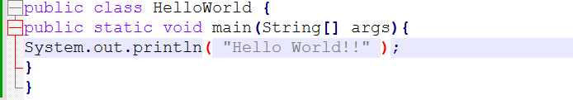

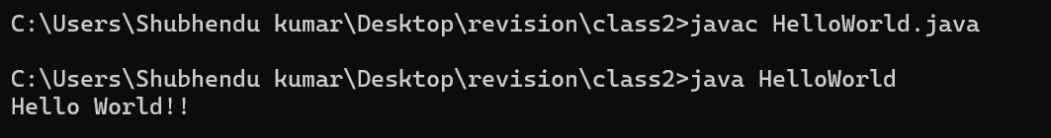

1. **Compile with Verbose Option**: Compile your Java file using the -verbose option with javac. Check the output.

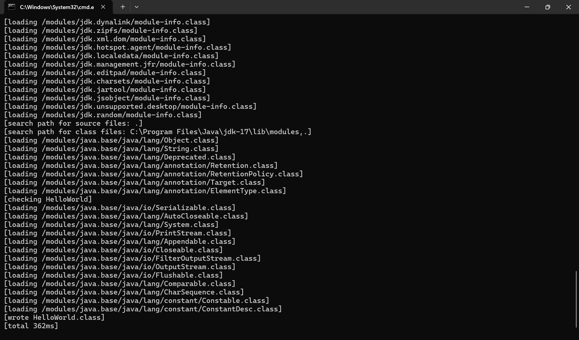

1. **Inspect Bytecode**: Use the javap tool to examine the bytecode of the compiled .class file. Observe the output.

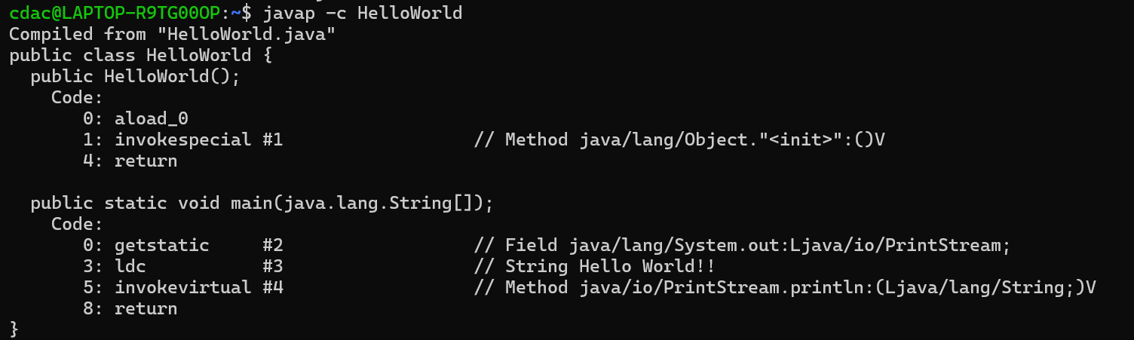

**7. Reading Assignment: The JVM Architecture Explained**

* **Task**: Learn about how the Java Virtual Machine (JVM) works.
* **Link**: https://dzone.com/articles/jvm-architecture-explained

**8. Reading Assignment: The Java Language Environment: Contents**

* **Task**: Explore the content and features of the Java language environment.
* **Link**: https://www.oracle.com/java/technologies/language-environment.html